# 请大家阅读文档时，在视图里勾选导航窗格，在左边显示章节目录方便浏览。

# 一、编程题1

下列代码定义了迭代器接口，数组迭代器和容器类：

*/**  
 * 迭代器接口，用于遍历组件树里的每一个组件. 注意这不是java.util.Iterator接口  
 */*interface Iterator {  
 */**  
 * 是否还有元素  
 \** ***@return*** *如果元素还没有迭代完，返回true;否则返回false  
 */* boolean hasNext();  
  
 */**  
 * 获取下一个元素  
 \** ***@return*** *下一个元素  
 */* Object next();  
}  
  
*/**  
 * 数组迭代器  
 */*class ArrayIterator implements Iterator{  
 private int pos = 0;  
 private Object[] a = null;  
  
 public ArrayIterator(Object[] array){  
 a = array;  
 }  
  
 @Override  
 public boolean hasNext() {  
 return !(pos >= a.length);  
 }  
  
 @Override  
 public Object next() {  
 if(hasNext()){  
 Object c = a[pos];  
 pos ++;  
 return c;  
 }  
 else  
 return null;  
 }  
}  
  
*/**  
 * 容器类，内部用Object[]保存元素  
 */*class Container {  
 private Object[] elements;  
 private int elementsCount = 0;  
 private int size = 0;  
  
 public Container(int size){  
 elements = new Object[size];  
 this.size = size;  
 }  
  
 public boolean add(Object e){  
 if(elementsCount < size){  
 elements[elementsCount ++] = e;  
 return true;  
 }  
 else{  
 return false;  
 }  
 }  
  
 */**  
 * 返回容器的迭代器  
 \** ***@return*** *\*/* public Iterator iterator(){  
 return new ArrayIterator(elements);  
 }  
}  
public class Test{  
 public static void main(String[] args){  
 Container container = new Container(6);  
 container.add("12");  
 container.add("34");  
 container.add("56");  
 container.add("78");  
 container.add("9");  
 container.add(10);  
 Iterator it = container.iterator();  
 while (it.hasNext()){  
 String s = (String)it.next();  
 if( s != null)  
 System.*out*.println(s);  
 }  
 }  
}

1. 上述代码存在什么问题？请分析存在问题的原因。

编译可以通过但是运行出错，原因是类型不匹配，前面的“12”，“34”，“56”，“78”，“9”都是string类型，但最后的10是一个整数类型，add语句不会出错，因为整型是object的一个子类，但下面String s=(String)it.next()会有问题，要求int类型强制转为String，类型不匹配。

2. 请将迭代器接口Iterator、数组迭代器ArrayIterator、容器Container分别改成泛型迭代器接口Iterator<T>、泛型数组迭代器ArrayIterator<T>、泛型容器Container<T>，并写出和上面一样的测试代码。要求泛型代码实现和非泛型接口/类同样的方法，另外泛型容器Container<T>也必须实现iterator方法。

代码：

/**

* 迭代器接口，用于遍历组件树里的每一个组件. 注意这不是java.util.Iterator接口

*/

interface Iterator <T> {

/**

* 是否还有元素

* @return 如果元素还没有迭代完，返回true;否则返回false

*/

boolean hasNext();

/**

* 获取下一个元素

* @return 下一个元素

*/

T next();

}

/**

* 数组迭代器

*/

class ArrayIterator<T> implements Iterator<T>{

private int pos = 0;

private Object[] a = null;

public ArrayIterator(T[] array){

a = array;

}

@Override

public boolean hasNext() {

return !(pos >= a.length);

}

@Override

public T next() {

if(hasNext()){

T c = (T)a[pos];

pos ++;

return c;

}

else

return null;

}

}

/**

* 容器类，内部用Object[]保存元素

*/

class Container<T> {

private Object[] elements;

private int elementsCount = 0;

private int size = 0;

public Container(int size){

elements = new Object[size];

this.size = size;

}

public boolean add(T e){

if(elementsCount < size){

elements[elementsCount ++] = e;

return true;

}

else{

return false;

}

}

/**

* 返回容器的迭代器

* @return

*/

public Iterator<T> iterator(){

return new ArrayIterator<T>((T[])elements);

}

}

public class Test{

public static void main(String[] args){

Container<String> container = new Container(6);

container.add("12");

container.add("34");

container.add("56");

container.add("78");

container.add("9");

container.add(10);

Iterator<String> it = container.iterator();

while (it.hasNext()){

String s = it.next();

if( s != null)

System.out.println(s);

}

}

}

测试结果：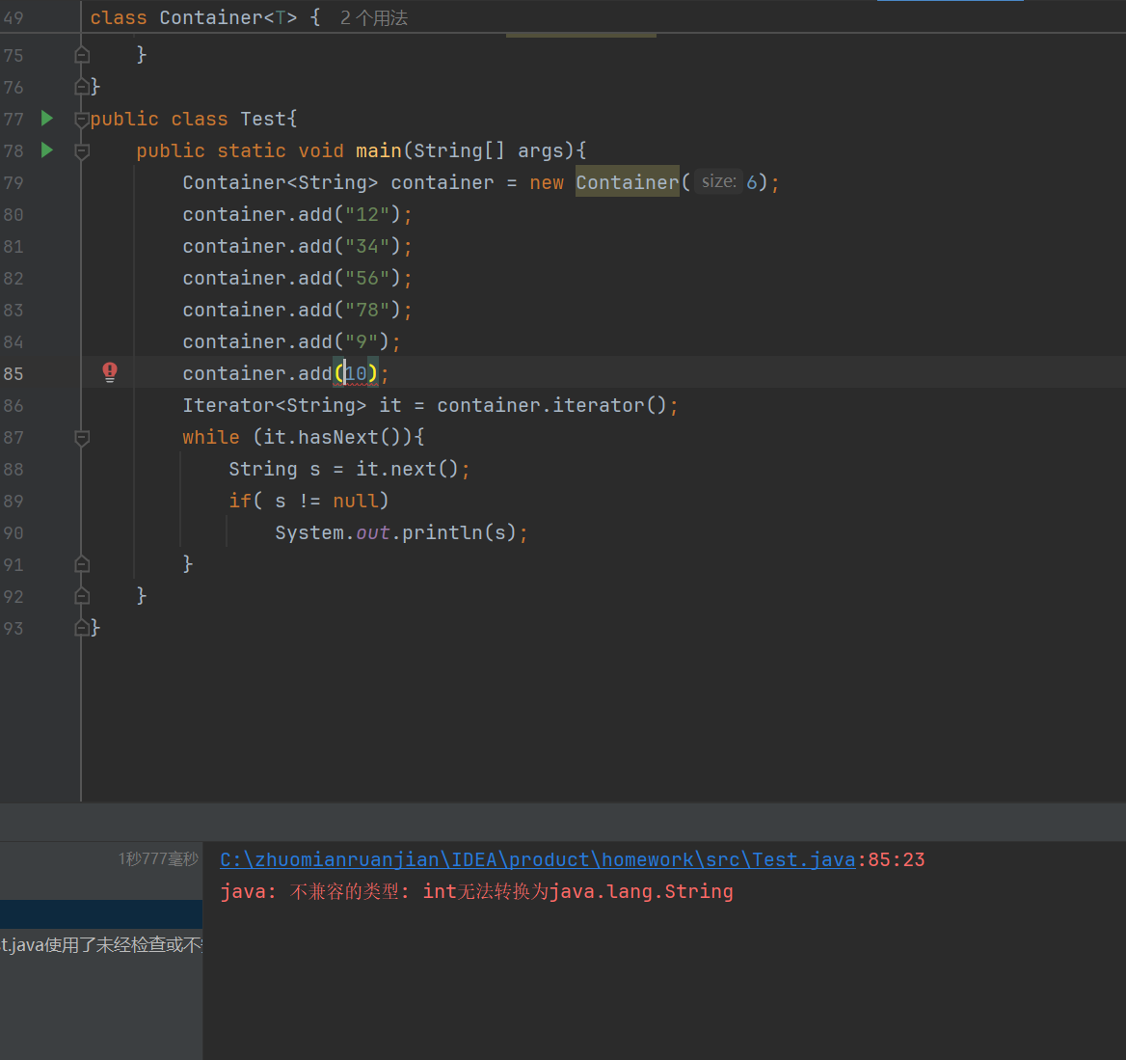

# 二、编程题2

实现一个泛型二元组类TwoTuple<T1, T2>，其中T1、T2分别是二元组第1个、第2个元素的类型参数，要求如下：

（1）T1、T2是实现了Comparable接口的类型；

（2）TwoTuple<T1, T2>必须实现Comparable接口；

（3）TwoTuple<T1, T2>必须覆盖equals方法和toString方法；

（4）TwoTuple<T1, T2>二个私有数据成员变量名分别为first, second；

（5）必须实现私有数据成员first, second的公有getter和setter方法;

（6）Comparable接口的compareTo方法实现的语义是：如果二个元组对象的first部分不相等，以二个对象first成员比较结果作为最终比较结果；如果二个元组对象的first部分相等，则以二个对象second成员比较结果作为最终比较结果；

（7）覆盖equals方法的实现语义是：二个元组对象的first和second分别都相等时，这个二个元组对象相等。

当实现好泛型类之后，通过下面的代码进行测试：

public static void main(String[] args){  
  
 TwoTuple<Integer,String> twoTuple1 =new TwoTuple<>(1, "ccc");  
 TwoTuple<Integer,String> twoTuple2 =new TwoTuple<>(1, "bbb");  
 TwoTuple<Integer,String> twoTuple3 =new TwoTuple<>(1, "aaa");  
 TwoTuple<Integer,String> twoTuple4 =new TwoTuple<>(2, "ccc");  
 TwoTuple<Integer,String> twoTuple5 =new TwoTuple<>(2, "bbb");  
 TwoTuple<Integer,String> twoTuple6 =new TwoTuple<>(2, "aaa");  
 List<TwoTuple<Integer,String>> list = new ArrayList<>();  
 list.add(twoTuple1);  
 list.add(twoTuple2);  
 list.add(twoTuple3);  
 list.add(twoTuple4);  
 list.add(twoTuple5);  
 list.add(twoTuple6);  
  
 //测试equals，contains方法是基于equals方法结果来判断  
 TwoTuple<Integer,String> twoTuple10 =new TwoTuple<>(1, "ccc"); //内容=twoTuple1  
 System.*out*.println(twoTuple1.equals(twoTuple10)); //应该为true  
 if(!list.contains(twoTuple10)){  
 list.add(twoTuple10); //这时不应该重复加入  
 }  
  
 //sort方法是根据元素的compareTo方法结果进行排序，课测试compareTo方法是否实现正确  
 Collections.*sort*(list);

for (TwoTuple<Integer, String> t: list) {  
 System.*out*.println(t);  
 }

TwoTuple<TwoTuple<Integer,String >,TwoTuple<Integer,String >> tt1 =  
 new TwoTuple<>(new TwoTuple<>(1,"aaa"),new TwoTuple<>(1,"bbb"));  
 TwoTuple<TwoTuple<Integer,String >,TwoTuple<Integer,String >> tt2 =  
 new TwoTuple<>(new TwoTuple<>(1,"aaa"),new TwoTuple<>(2,"bbb"));  
 System.*out*.println(tt1.compareTo(tt2)); //输出-1  
 System.*out*.println(tt1);

}

上述测试代码的输出结果应为：

true

(1, aaa)

(1, bbb)

(1, ccc)

(2, aaa)

(2, bbb)

(2, ccc)

-1

((1, aaa), (1, bbb))

代码：

import java.util.*;

class TwoTuple<T1 extends Comparable, T2 extends Comparable> implements Comparable {

T1 t1;

T2 t2;

public TwoTuple(T1 t1, T2 t2) {

this.t1 = t1;

this.t2 = t2;

}

public T1 getT1() {

return t1;

}

public T2 getT2() {

return t2;

}

public void setT1(T1 t1) {

this.t1 = t1;

}

public void setT2(T2 t2) {

this.t2 = t2;

}

@Override

public boolean equals(Object o) {

if(o instanceof TwoTuple) {

TwoTuple twoTuple = (TwoTuple) o;

return Objects.equals(this.t1, twoTuple.t1) && Objects.equals(this.t2, twoTuple.t2);

}

return false;

}

public int compareTo(Object o) {

if(o instanceof TwoTuple) {

TwoTuple twoTuple = (TwoTuple) o;

if(!this.t1.equals(twoTuple.t1)) {

return this.t1.compareTo(twoTuple.t1);

}

else {

return this.t2.compareTo(twoTuple.t2);

}

}

return -1;

}

public String toString() {

return "(" + t1.toString() + ", " + t2.toString() + ")";

}

}

public class TTest {

public static void main(String[] args){

TwoTuple<Integer,String> twoTuple1 =new TwoTuple<>(1, "ccc");

TwoTuple<Integer,String> twoTuple2 =new TwoTuple<>(1, "bbb");

TwoTuple<Integer,String> twoTuple3 =new TwoTuple<>(1, "aaa");

TwoTuple<Integer,String> twoTuple4 =new TwoTuple<>(2, "ccc");

TwoTuple<Integer,String> twoTuple5 =new TwoTuple<>(2, "bbb");

TwoTuple<Integer,String> twoTuple6 =new TwoTuple<>(2, "aaa");

List<TwoTuple<Integer,String>> list = new ArrayList<>();

list.add(twoTuple1);

list.add(twoTuple2);

list.add(twoTuple3);

list.add(twoTuple4);

list.add(twoTuple5);

list.add(twoTuple6);

//测试equals，contains方法是基于equals方法结果来判断

TwoTuple<Integer,String> twoTuple10 =new TwoTuple<>(1, "ccc"); //内容=twoTuple1

System.out.println(twoTuple1.equals(twoTuple10)); //应该为true

if(!list.contains(twoTuple10)){

list.add(twoTuple10); //这时不应该重复加入

}

//sort方法是根据元素的compareTo方法结果进行排序，课测试compareTo方法是否实现正确

Collections.sort(list);

for (TwoTuple<Integer, String> t: list) {

System.out.println(t);

}

TwoTuple<TwoTuple<Integer,String >,TwoTuple<Integer,String >> tt1 =

new TwoTuple<>(new TwoTuple<>(1,"aaa"),new TwoTuple<>(1,"bbb"));

TwoTuple<TwoTuple<Integer,String >,TwoTuple<Integer,String >> tt2 =

new TwoTuple<>(new TwoTuple<>(1,"aaa"),new TwoTuple<>(2,"bbb"));

System.out.println(tt1.compareTo(tt2)); //输出-1

System.out.println(tt1);

}

}

结果截图：

